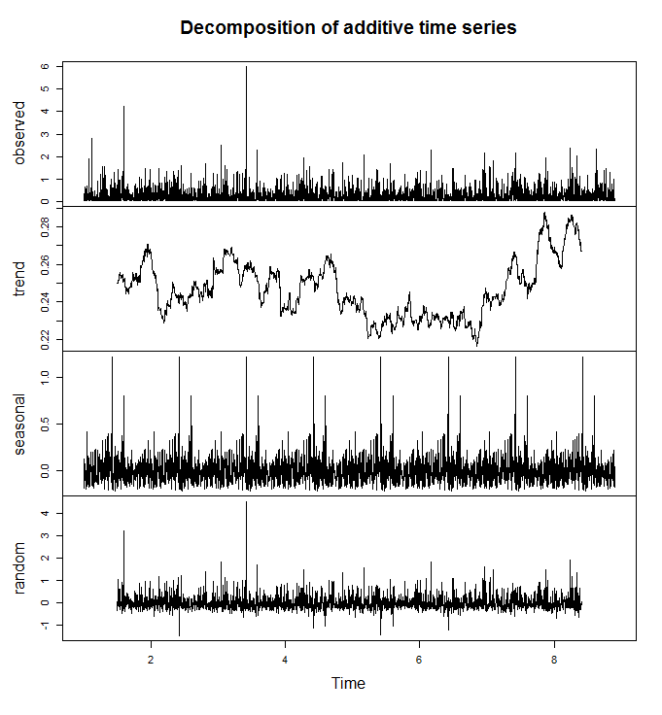**Name:** Art Link

1. (3 points) **TS$A=as.POSIXct(paste0(TS$DATE),format="%Y%m%d")**
2. 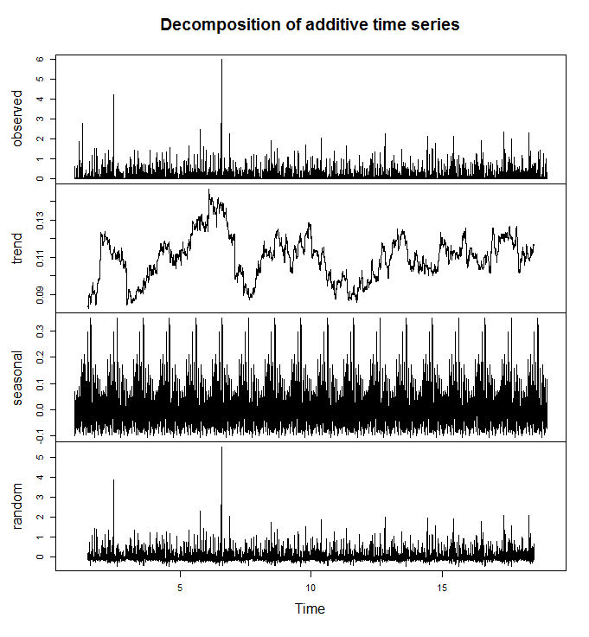(2 points) **This depends on how you interpret the data. If you do not include zeros, you get the first figure (top). If you do include the zeros, you get the second (bottom). With the first, there has been an increase in precipitation, especially in the last couple years. There has been a stagnant amount of precipitation from around 1999 until 2005 and then a small drop around 2012. Again, there is a noticeable increase in the last couple years. With the second figure, there has been overall an increase. It does not have as many valleys as past periods have. Overall this figure shows that precipitation has stagnated and stayed relatively steady. This is very important to consider when conveying data to the public.**
3. (2 points) **Both figures show that there are periodic trends in precipitation. This can be seen in the seasonal section of the figures. It seems like precipitation is always present in PA, who would have thought that?**
4. (3 points) **There does not seem to be an increase in mean maximum temperature given the figure below.**

